Ideation Phase
Define the Problem Statements

Date | 08 DECEMBER 2025
Team ID (Skillwallet ID) | SWUID202560126
Project Name | Freelancing Application
Maximum Marks | 2 Marks

Customer Problem Statement Template:
To define the core problems freelancers face while searching for jobs online, and use those insights to guide the development of Freelance Finder.
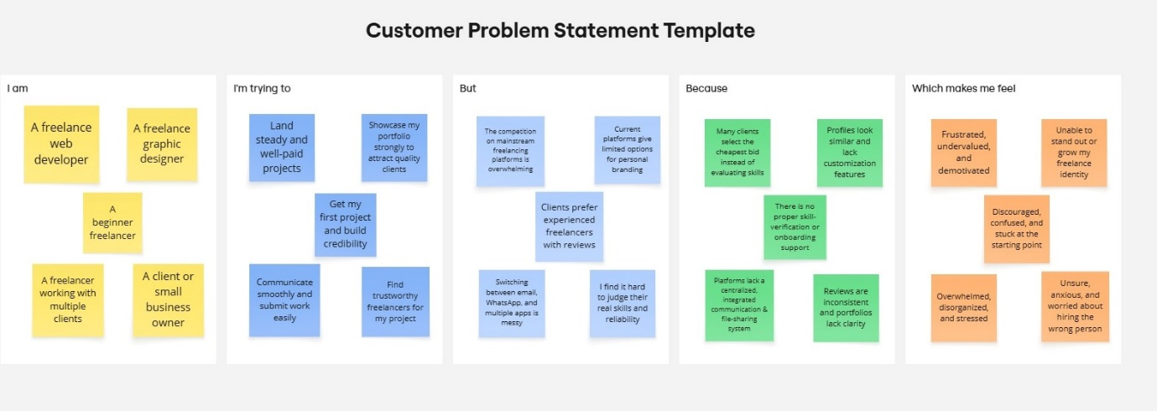

Problem Statement (PS) | I am (Customer) | I’m trying to | But | Because | Which makes me feel
PS-1 | A freelance web developer. | Find consistent and fairly paid projects | The competition on existing freelancing platforms is extremely high | Clients often choose the cheapest bid instead of evaluating skills | Frustrated, undervalued, and insecure about my career
PS-2 | A freelance graphic designer | Showcase my portfolio strongly to attract quality clients | Current platforms give limited options for personal branding | Profiles look similar and lack customization features | Unable to stand out or grow my freelance identity

PS-3 | A beginner freelancer | Get my first project and build credibility | Clients prefer experienced freelancers with reviews | There is no proper skill-verification or onboarding support | Discouraged, confused, and stuck at the starting point
PS-4 | A client or small business owner | Find trustworthy freelancers for my project | I find it hard to judge their real skills and reliability | Reviews are inconsistent and portfolios lack clarity | Unsure, anxious, and worried about hiring the wrong person
PS-5 | A freelancer working with multiple clients | Communicate smoothly and submit work easily | Switching between email, WhatsApp, and multiple apps is messy | Platforms lack a centralized, integrated communication & file-sharing system | Overwhelmed, disorganized, and stressed

